A000-Mex-Baja-San Antonio Necua Village-Guanjatel venado deer-Kumeyaay Basket- by Rosa Maria Gorro-1997

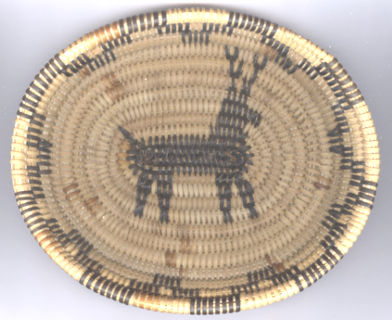

Fig. 1. Mex-Baja-San Antonio Necua Village-Guanjatel venado deer-Kumeyaay Basket- by Rosa

Case No.: 12

**Accession No. A000**

**Formal Label:** Mex-Baja-San Antonio Necua Village-Guanjatel venado deer-Kumeyaay Basket- by Rosa Maria Gorro-1997

**Display Description:**

This coiled Kumeyaay basket is called *Chitay incienso* and was woven by Rosa Maria Gorro of San Antonio Necua village, with a central image of Guanjatel, a deer.

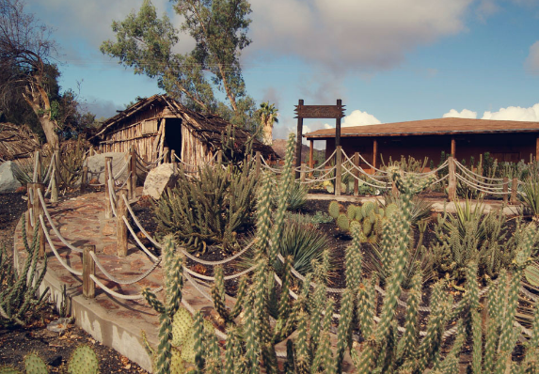

San Antonio Necua village. After http://bajacaliforniabest.com/wp-content/uploads/principal-museo-sinaw-kuatay-san-antonio-necua.jpg

Like most California Indians, the Kumeyaay were sophisticated basket makers weaving fine, tightly stitched baskets. Some were worn as hats by both men and women. In addition to protecting the head, they could be used as bowls for water or for carrying items. Larger baskets were traditionally used for processing foods, especially seeds and nuts, and for cooking. This small basket could have been worn as a cap. The image of a deer is important for the economy of the Kumeyaay for once they were nomadic and depended on game. The numerous paintings of deer in rock shelters in the San Francisco Mountains of Baja attest to this dependence on game. The basket on display show a deer that has been imaged by spirally coiling grasses in a spiral with expert measuring so that the image would come out perfectly. This is one of the hall marks of the coiled Kumeyaay basketry or *Chitay incienso.*

Each Kumeyaay band had a central village where the *kwaaypaay* social leader and the *kuseyaay* shaman lived and managed the ceremonial center. The religious year was observed by solstice and equinox ceremonies, all managed by the shaman, who had great knowledge of herbal medicine and curing songs and ceremonies. Shamans were also astronomers, knowing the movements of the stars through the seasons and phases of the moon, which determined the timing of harvest and ceremonies such as naming, puberty rites and marriage.

The Kumeyaay, also known as Tipai-Ipai, formerly Kamia or Diegueño,. The term Kumeyaay means "those who face the water from a cliff".[[3]](https://en.wikipedia.org/wiki/Kumeyaay" \l "cite_note-3), it may also come from the Kiliwa word *kumeey* meaning "man human being" or "people." Both *"Ipai/Iipay"* and *"Tipai"* mean "man human being" or "people."[[4]](https://en.wikipedia.org/wiki/Kumeyaay" \l "cite_note-luomala592-4) Some Kumeyaay in the southern areas also refer to themselves as *MuttTipi*, which means "people of the earth."



Early 19th century Schott, Sorony, Co. NY 1857

These bands are classified together as Kumeyaay because they are all of the Yumanlanguagefamily**,**Hokanstock. The Kumeyaay are sub-divided into the Ipai (the northern dialectical form) and the Tipai (the southern dialectical form) and the Kamia (the eastern dialectical form mentioned above).

The Ipai lived in territory extending from the San Diego River (approximately Interstate 8) north to Agua Hedionda Lagoon (approximately State Highway 78) and then eastward through Escondido to Lake Henshaw. The Tipai lived south of the San Diego River into Baja south of Ensanada, and eastward to the Laguna Mountains and beyond Mount Tecate.

Spanish missionaries tried to convert the Kumeyaay to Christianity using presidio soldiers to subdue them, and many bands resented this intrusion and remained some of the most resistant of all California Indians to subjugation, revolting on several occasions. On November 4 and 5, 1775, a force of Kumeyaay surrounded Mission San Diego de Alcalá, set fire to its wooden structures and attacked a small contingent of Spaniards. The padre and another Spaniard were killed (the only missionary killed by Indians in California) which prompted expeditions by Presidio soldiers into the mountains and deserts to the east, in search of the Indian leaders and new neophytes for the mission.

This tenuous relationship between the Kumeyaay and the Spanish continued until Mexican independence in 1821. Nonetheless, by the time of mission secularization, the Kumeyaay population had dwindled to about 3,000 due to disease, loss of ancestral lands and various other causes. Freed of mission control, most Kumeyaay fled to the mountains where they could not be forced to work for the Mexican settlers or the army, and the population started to rebuild.

When the U.S. wrested control of California from Mexico with the Treaty of Guadalupe Hidalgo in 1848, most of the mountain Kumeyaay, especially those along the emigrant trails, were seriously affected by the entrance of American settlers. By the time gold was discovered in Julian in 1869, shortly after the Civil War, the Spanish, Mexican and American governments and settlers had changed the Kumeyaay's way of life forever.

In 1875, the inland Kumeyaay were expelled from their ancestral homes and their land was expropriated. Their plight was ignored until publicity generated by the Indian Rights Association and the Sequoia League forced the BIA (Bureau of Indian Affairs) to set aside lands of the Cuyamaca, La Posta, Manzanita and Laguna Mountains earlier in this century.

The Kumeyaay population finally began to revive after 1910. Currently there are about 20,000 Kumeyaay descendants in San Deigo County, about 10% of whom live on its 18 reservations, more than in any other county in the United States.

**LC Classification:**

**Date or Time Horizon:**

**Geographical Area:**

**Map**

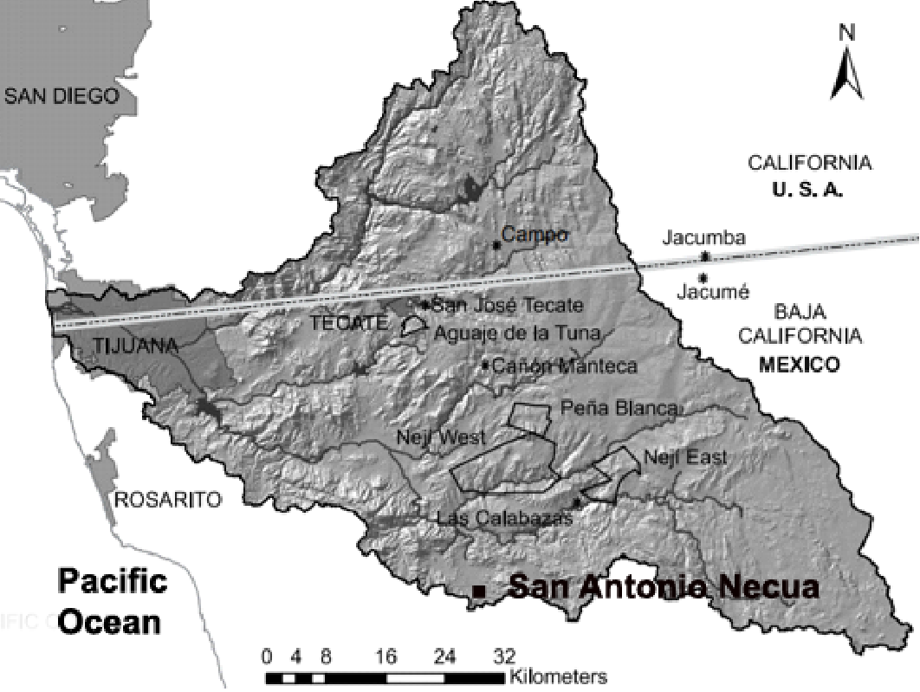

After

**GPS coordinates:**

**Cultural Affiliation:**

**Media:**

**Dimensions:**

**Weight:**

**Condition:**

**Provenance:**

**Discussion:**

**References:**

* Hoffman, Geralyn Marie; Gamble, Lynn H. 2006. A Teacher’s Guide to Historical and Contemporary Kumeyaay Culture, Institute for Regional Studies of the Californias, San Diego State University.
* Kroeber, A. L. 1925. "Handbook of the Indians of California", Bureau of American Ethnology Bulletin, Washington, DC
* Langdon, Margaret 1990. Redden, James E., ed., "Diegueño: how many languages?", Proceedings of the 1990 Hokan-Penutian Languages Workshop, University of Southern Illinois, Carbondale: 184–190.
* Luomala, Katharine 1978. "Tipai-Ipai", in Heizer, Robert F., Handbook of North American Indians, 8 California, Washington, DC: Smithsonian Institution, pp. 592–609.
* Pritzker, Barry M. 2000. "Tipai-Ipai", A Native American Encyclopedia: History, Culture, and Peoples, Oxford: Oxford University Press, pp. 145–147.
* Shipek, Florence C. 1978. "History of Southern California Mission Indians", in Heizer, Robert F., Handbook of North American Indians, Washington, DC: Smithsonian Institution, pp. 610–618.
* Shipek, Florence C. 1986. "The Impact of Europeans upon Kumeyaay Culture", in Starr, Raymond, The Impact of European Exploration and Settlement on Local Native Americans, San Diego: Cabrillo Historical Association, pp. 13–25.